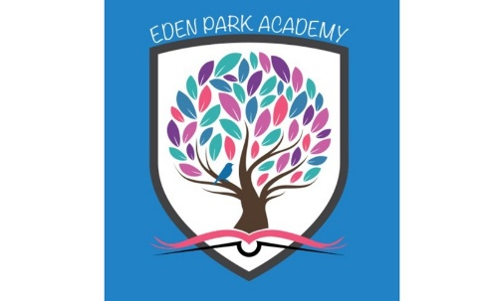

Intent for EYFS
Eden Park Academy
‘The development of children’s spoken language underpins all seven areas of learning and development. Children’s back and forth interactions from an early age form the foundations for language and cognitive development. The number and quality of the conversations they have with adults and peers throughout the day in a language-rich environment is crucial. ‘
Communication and Language Educational Programme – Statutory Framework September 2021

At Eden Park Academy we expect that every child will leave the Early Years with a wide range of vocabulary, the ability to interact with both their peers and adults and will be able to enunciate sounds at an age-appropriate level.

We achieve this through:
- A language-centred curriculum built around research and pedagogy to meet the needs for all of our children.

- A spiral curriculum based on Bjork’s research on spacing and interleaving.

- Use of Blank Language Levels to inform the pitch of adult-child interactions and questioning level (Nursery lead completed Elklan training July 2022)

- Robust assessment systems which all have a formative value.

- Spine of key texts which link to concepts taught through the language led learning approach.

- Intellectual progression layered across the curriculum.

- Learning environment and provision linked to the language-centred curriculum to provide greater impact through adult-child interactions.

- Skilled modelling of vocabulary and appropriate interactions (blanks) by staff
- Supporting parents to understand how to best support their child’s vocabulary and language development through weekly updates

